Project Design Phase-I
Solution Architecture

Date | 31 January 2026
Team ID | LTVIP2026TMIDS28502
Project Name | Visualizing Housing Market Trends: An Analysis of Sale Prices and Features using Tableau
Maximum Marks | 4 Marks

Solution Architecture Diagram:

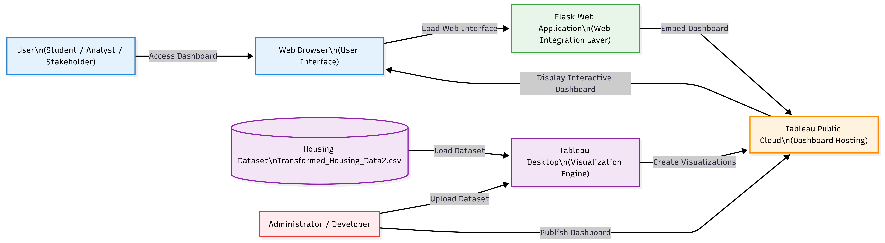

Solution Architecture:
The solution architecture for the Housing Market Visualization System is designed to transform raw housing data into meaningful visual insights using Tableau and web integration technologies. The architecture bridges the gap between raw data and user-friendly visualization by organizing the system into multiple layers, including the Data Layer, Visualization Layer, Cloud Hosting Layer, Web Integration Layer, and User Interaction Layer.
The process begins with the housing dataset stored in CSV format on the local system. This dataset contains important attributes such as sale price, house age, renovation status, number of bedrooms, bathrooms, floors, and basement area. This dataset acts as the primary data source for the visualization system.
In the Visualization Layer, Tableau Desktop is used to load, process, and analyze the dataset. Tableau performs data preparation, identifies measures and dimensions, and generates various visualizations such as KPI indicators, bar charts, pie charts, and comparative feature analysis charts. These visualizations are then combined into an interactive dashboard and story format to provide structured and meaningful insights.
In the Cloud Hosting Layer, the created dashboards are published to Tableau Public, which serves as a cloud-based platform for hosting and sharing visualizations. Tableau Public securely stores the dashboards and provides a public access link that allows users to view and interact with the visualizations from any location.
In the Web Integration Layer, a Flask web application is used to embed the Tableau dashboard using an iframe. Flask acts as the web interface that connects users with the Tableau Public dashboard. This integration enables users to access the dashboard through a web browser without directly opening Tableau Public.
In the User Interaction Layer, users such as students, analysts, and stakeholders access the system through a web browser. They can interact with the dashboard by applying filters, exploring visualizations, and analyzing housing trends. This interaction allows users to gain insights into factors affecting housing sale prices and structural characteristics.
This architecture ensures efficient data processing, easy accessibility, and interactive visualization. It also provides scalability by allowing additional datasets, dashboards, and visualization features to be added in the future. The use of Tableau Public cloud hosting ensures availability, while Flask integration enhances accessibility and usability through a web-based interface.

